**Link2Care COVID-19 report**

Created: April 26, 2021

Updated: April 27, 2021

The date used to delineate pre-COVID from post-COVID in all analyses below is 2020-03-13.

**Figure 3.** Monthly recruitment stratified by year.

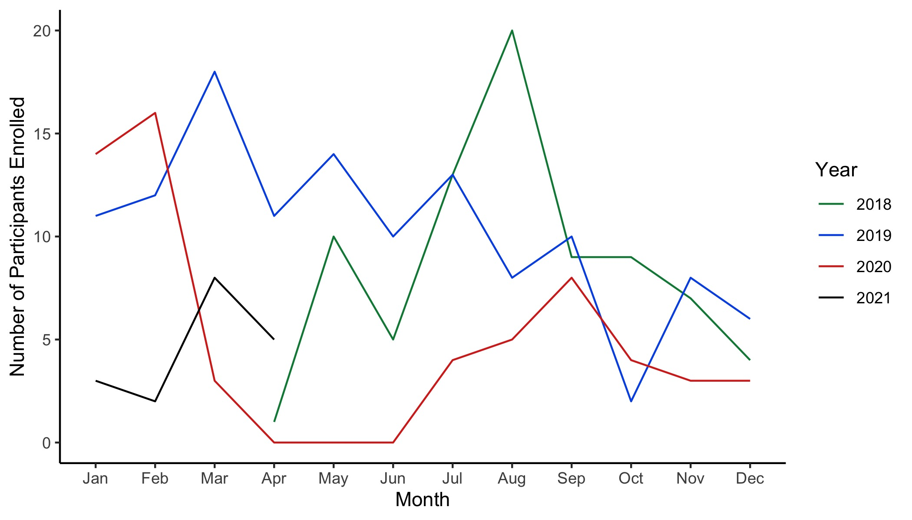

**Table**. Grouping and compliance (n = 259 people who completed visit 2) by COVID (pre/post)

| visit | completed   pre | scheduled   pre | prop   pre | completed   post | scheduled   post | prop   post |
| --- | --- | --- | --- | --- | --- | --- |
| v3 | 151 | 204 | 0.74 | 40 | 55 | 0.73 |
| v4 | 109 | 187 | 0.58 | 39 | 72 | 0.54 |
| v5 | 94 | 172 | 0.55 | 46 | 87 | 0.53 |

The denominator changes at each visit because some people's visits straddle 2020-03-13. So, you can't say that everybody how had a v3 scheduled pre-covid also had a v4 scheduled pre-covid.

**Table**. Count of missing anthropometric measures by COVID (pre/post)

| covid | weight | height | waist_c | co |
| --- | --- | --- | --- | --- |
| Pre-COVID | 0 | 0 | 1 | 18 |
| Post-COVID | 55 | 55 | 55 | 61 |

**Table**. Alcohol consumption by COVID (pre/post)

| covid | min | median | mean | max |
| --- | --- | --- | --- | --- |
| Pre-COVID | 0 | 0 | 8.145051 | 77 |
| Post-COVID | 0 | 0 | 6.903226 | 57 |